Christmas songs

Jingle bells
Jingle bells, Jingle bells, Jingle all the way,
Oh what fun it is to ride on a one horse open sleigh, hey!
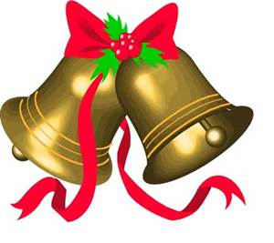
Christmas Pudding
Christmas pudding, Christmas pudding,
Steaming hot, steaming hot,
Sprinkle on the sugar, sprinkle on the sugar,
Eat the lot, Eat the lot.

Father Christmas, Father Christmas,
He got stuck, he got stuck,
Coming down the chimney, coming down the chimney,
What bad luck, what bad luck.

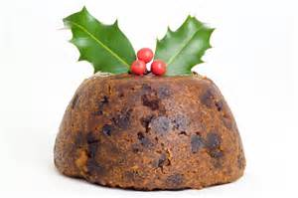

Rudolf, Rudolf
Rudolf, Rudolf don’t you stop,
Just let your feet go clipperty clop,
Your nose is red and your eyes are round,
Giddy up, we’re Christmas bound!
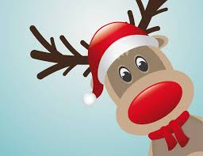
When Santa got stuck up the Chimney
When Santa got stuck up the chimney he began to shout,
You girls and boys won’t get any toys if you don’t pull me out!
My beard is black, there’s soot in my sack, my nose is tickly too,
When Santa got stuck up the chimney,
Achoo, achoo, achoo!
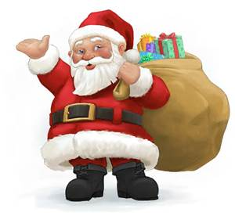

We wish you a Merry Christmas
We wish you a Merry Christmas,
We wish you a Merry Christmas
We wish you a Merry Christmas and a happy new year!

